create table salesman(

salesman_id int not null primary key,

name char(255),

city varchar(255),

commission float

);

create table orders(

ord_no int not null primary key,

purchase_amnt float,

ord_date varchar(255),

customer_id varchar(255),

salesman_id varchar(255)

);

create table customers(

customer_id varchar(255) not null primary key,

customer_name char(255),

city char(255),

grade varchar(255),

salesman_id varchar(255)

);

------------------

insert into salesman(salesman_id, name, city, commission)

values('5001', 'James Hoog', 'New york', '0.15');

insert into customers(customer_id, customer_name, city, grade, salesman_id)

values('3001', 'John Brad', 'Moscow', 'Null', '5003');

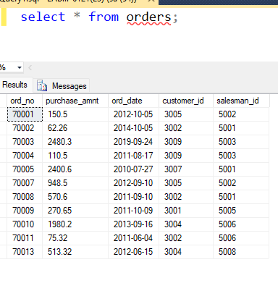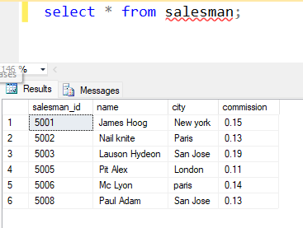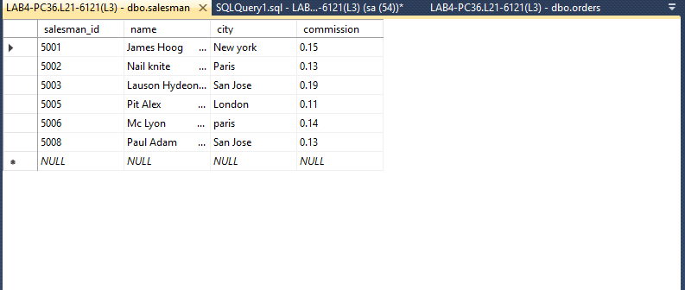

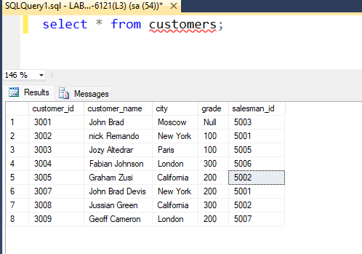

1. 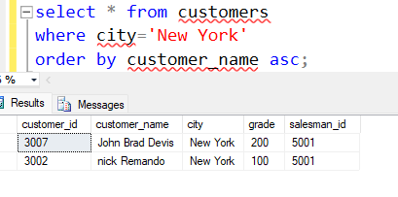
2. 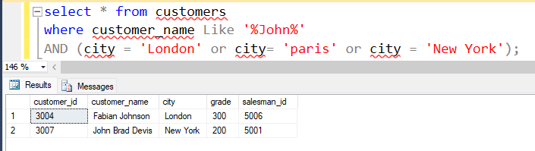
3. 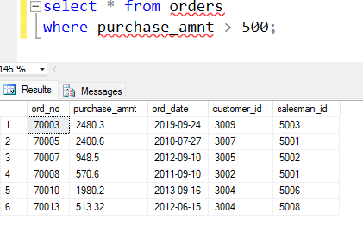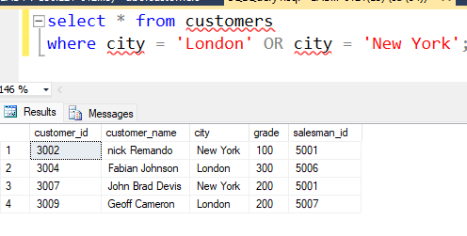



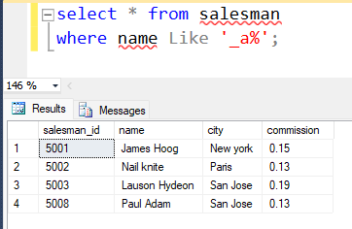

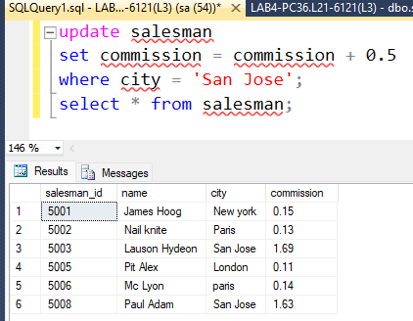



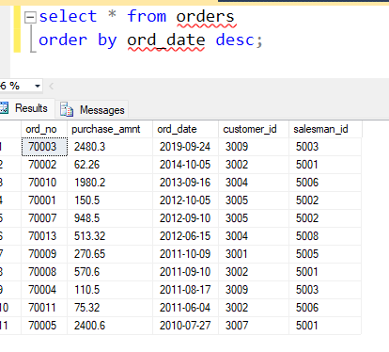



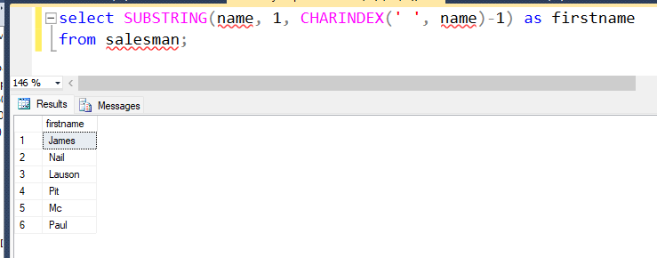



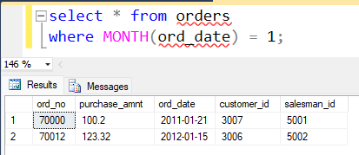



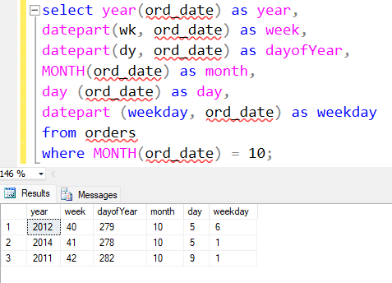

1. 